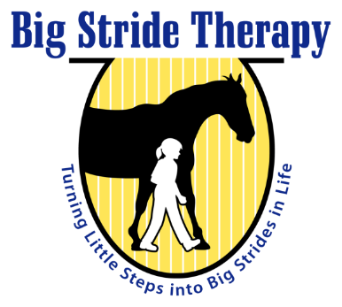

HIPPOTHERAPY PROGRAM GUIDELINES & PROCEDURES

Dear Parents:

Welcome to our hippotherapy program! Rest assured that your child’s safety comes first and foremost! We strictly abide by all Path Intl. regulations for safe and quality therapy.

REQUIREMENTS:

The following information and prescriptions must be received before your child can begin participation in the Hippotherapy program:

- Completion of the new patient forms.
- A copy of your child’s most recent IEP or IFSP and most recent OT evaluation and progress reports.
- Two prescriptions from your child’s doctor, one that prescribes Occupational therapy” (not hippotherapy) and a separate one that allows medical clearance for horseback riding or “hippotherapy”. These will be on Big Stride Therapy Paperwork.
- For Down syndrome children, a statement of medical clearance for Atlantoaxial Stability.
- Signed liability release form.
- For Medicaid only clients, please note we will have to obtain a prior approval from Medicaid before starting therapy. If the child is already receiving therapy, you are responsible to find out if they already have a PA in place. We must work with the other therapy company to get a PA for both companies at the same time.

In addition, we request that you follow these guidelines to help us assure the best experience for your child.

GUIDELINES FOR ALL RIDERS:

The barn is allowing us to carry out the therapy programs at their barn using their horses. Please show respect for their premises, staff and horses.

- For safety, please stay with your child until the therapist is ready to take over. We have a huge responsibility to maintain a safe environment with large animals. Our horses are wonderful and well trained but can respond quickly if frightened. They are “flight” animals and unusual sounds or sights can cause them react in a dangerous manner. It is also important to maintain supervision of siblings or friends brought on property. We are here to provide therapy using the movement of the horse, and distractions can affect the therapy and create an unsafe environment.
- Please dress your child appropriately. Closed-toe shoes, long socks in the cold weather, gloves and even a beanie for under the helmet. In warm weather, bring a water bottle and wear sunscreen.
- No smoking in or around the barn.
- No dogs or other animals without prior approval.
- Please do not pet or feed the horses without permission.
- Gates will be closed during therapy sessions.
- No one should be in the ring during therapy sessions except the treatment team and the child.
- We have ASTM/SEI approved riding helmets for your use at the farm. It is strongly recommended that you get your child use to wearing a helmet of some type at home (this could be an inexpensive bicycle helmet) since this is usually our biggest obstacle on the first day. If you are doing hippotherapy for a reasonable period of time, it is preferred that you purchase your child his/her own approved riding helmet so it is always adjusted for a good, safe fit.

CANCELLATIONS:

A minimum of 24 hours notification of Cancellation is required. Please let the therapist know as far as in advance as possible about scheduled vacations, etc. In the case of sudden illness, please call as soon as possible. Also, please bear in mind that the volunteers are scheduled two or three days in advance for your child’s session. We must also have sufficient notice to cancel their time. The therapist’s time is valuable and she can readjust her schedule if advance notification is given. If you cancel within 24 hours, you will still be responsible for the barn fee as the horse has been scheduled and the barn will still have to be paid.

BARN FEES:

The stable where Big Stride Therapy is housed, requires a “facility fee”. This reserves your regularly scheduled time slot each week. It also covers the cost of the lease (use) of the horse for the therapy session, the use of the facility, and the costs involved in recruiting, training, and managing the volunteers needed to lead the horse and side walk for the child’s safety. Please bear in mind that the hippotherapy horses are very expensive to support, (hay, grain, horseshoes, wormers, shots, vet, extra training etc.).

The barn fee is paid directly to the barn. Depending on the barn, it is between $100 and $150 per month. Some months have 5 weeks so it averages out over the year. If you miss a session due to illness or vacation, please try to reschedule for another available time. If the therapist is out, every effort will be made to reschedule the therapy sessions. In the case of weather cancelations that cannot be made up, we will prorate the next month.

We look forward to continuing to provide your child with a very high quality program. This fee is due on the first day of each month that your child is enrolled in the program.
PLEASE NOTE: INSURANCE OR MEDICAID DOES NOT COVER BARN FEES!

Please sign the attached agreement, separate, and return with your other enrollment paperwork. Please retain a copy of these Guidelines and Procedures for your reference.
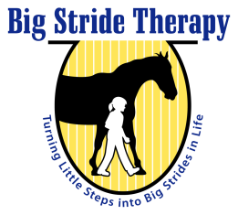 | HIPPOTHERAPY GUIDELINES AND PROCEDURES | 150 Foal Drive, Roswell, GA 30076  Phone: 678-665-2926  FAX: 770-650-9696  www.bigstridetherapy.com  bernie@bigstridetherapy.com
I, ________________________________ have read and agree to adhere to the barn rules and agree to pay the barn/facility fee every month that my child is enrolled in hippotherapy. I understand that the fee is paid per month for weekly 60-minute sessions. This fee reserves my weekly appointment time and covers the lease of the horse, the facility and the volunteer recruitment and management costs. I further understand that a one months’ notice of cancellation for withdrawal from the program is required.

- I understand I am financially responsible for claims not paid by insurance for services provided by Big Stride Therapy.
- I understand I am responsible for any and all charges, copays that are not paid by my insurance.

Date Client Name Signature of Parent or Guardian

- I have read and understand the HIPAA rules and regulations.

Date Client Name Signature of Parent or Guardian
Please sign and return this form along with your other hippotherapy paperwork. Keep the guidelines and a signed copy for your records. Thank you.

